ASSIGNMENT 5

Q.1

WHAT IS KS-TEST?

The [Kolmogorov-Smirnov Test](https://www.geeksforgeeks.org/ml-kolmogorov-smirnov-test/) is a type of non-parametric test of the equality of discontinuous and continuous of a 1D probability distribution that is used to compare the sample with the reference probability test (known as one-sample K-S Test) or among two samples (known as two-sample K-S test). A K-S Test quantifies a distance between the cumulative distribution function of the given reference distribution and the empirical distributions of given two samples, or between the empirical distribution of given two samples.

NECESSITY TO PERFORM KS-TEST

The Kolmogorov–Smirnov test is a nonparametric goodness-of-fit test and is used to determine whether two distributions differ, or whether an underlying probability distribution differs from a hypothesized distribution. It is used when we have two samples coming from two populations that can be different.

STEPS TO PERFORM IN KS-TEST IN R

Step1:

Install the require packages.

a. To perform KS test in R is dgof.

b. Use install.packages() function from the R console.

Step2:

Load the package with the Library() in R console.

Step3: Generate random variables with rnorm( ) and random deviations with

runif( ).

Step4:

Perform KS test with ks.test( ) function.

OUTPUT:

SOURCE CODE:

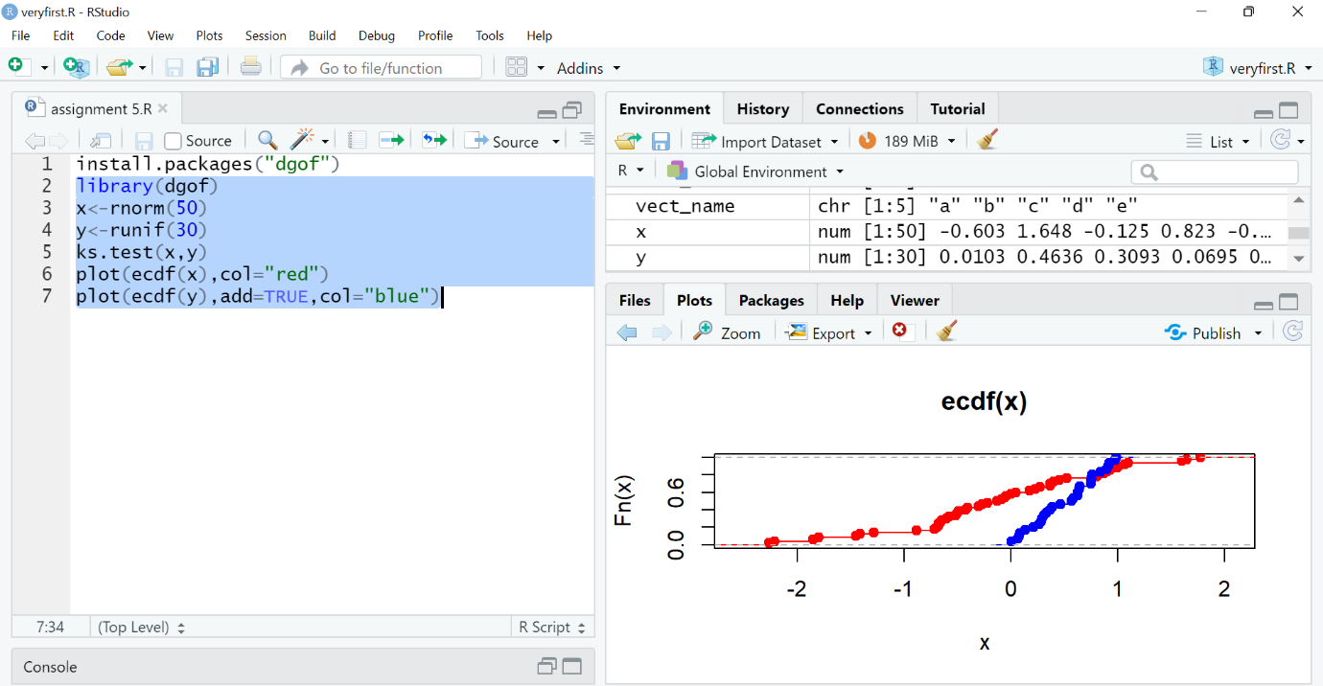

CONSOLE:

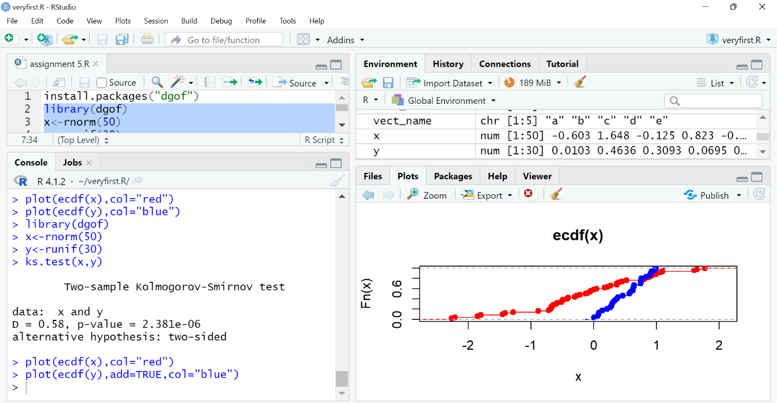

GRAPH:

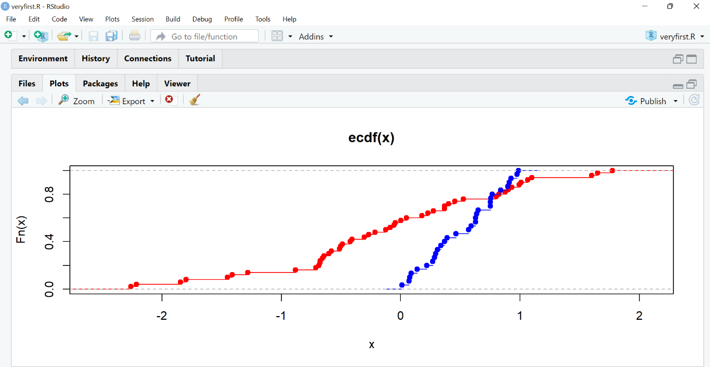

Q.2

a.

source code and console:

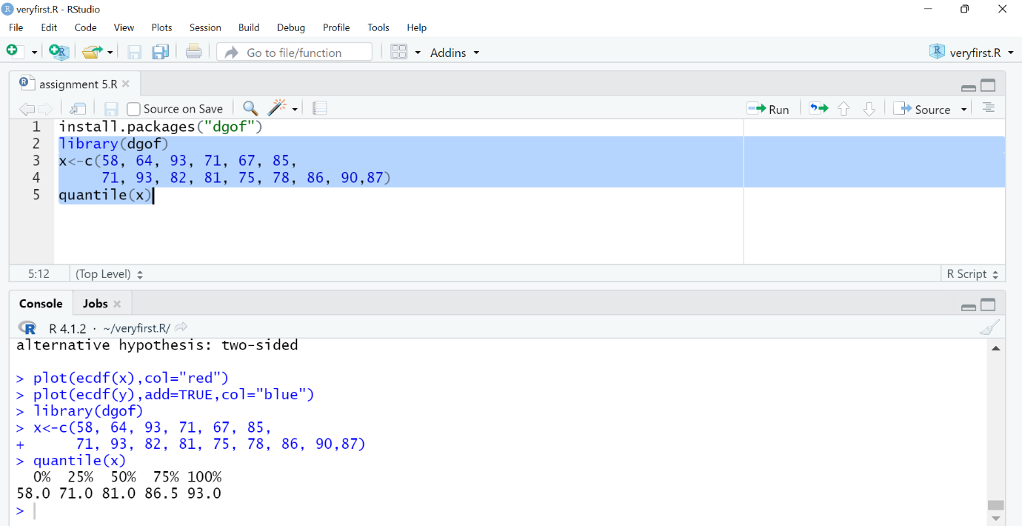

Result:

0% 25% 50% 75% 100%

58.0 71.0 81.0 86.5 93.0

0% - of the total students have score less than 58

25% - of total students have score less than 71

50% - of total students have score less than 86.5

100% - of total students have score less than or equal to 93

b.

source code and console:



Result:

0% 50

7.142857% 52

14.28571% 57

21.42857% 58

28.57143% 62

35.71429% 65

42.85714% 66

50% 68

57.14286% 69

64.28571% 72

71.42857% 74

78.57143% 75

85.71429% 77

92.85714% 84

100% 87

c.

source code and console:

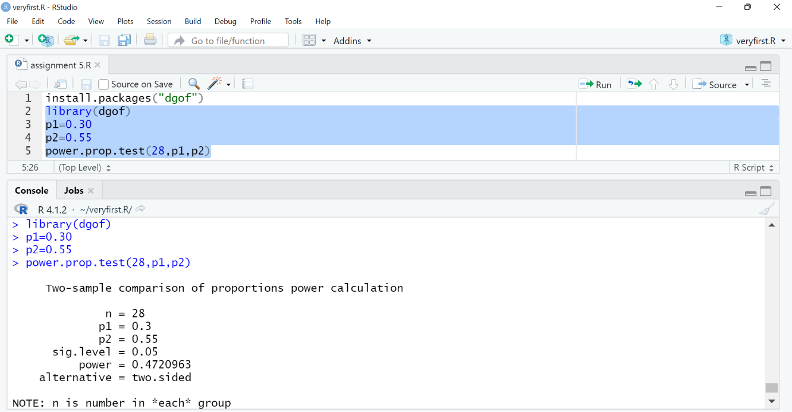

RESULT:

Two-sample comparison of proportions power calculation

n = 28

p1 = 0.3

p2 = 0.55

sig.level = 0.05

power = 0.4720963

alternative = two.sided

NOTE: n is number in *each* group

d.

source code and console:

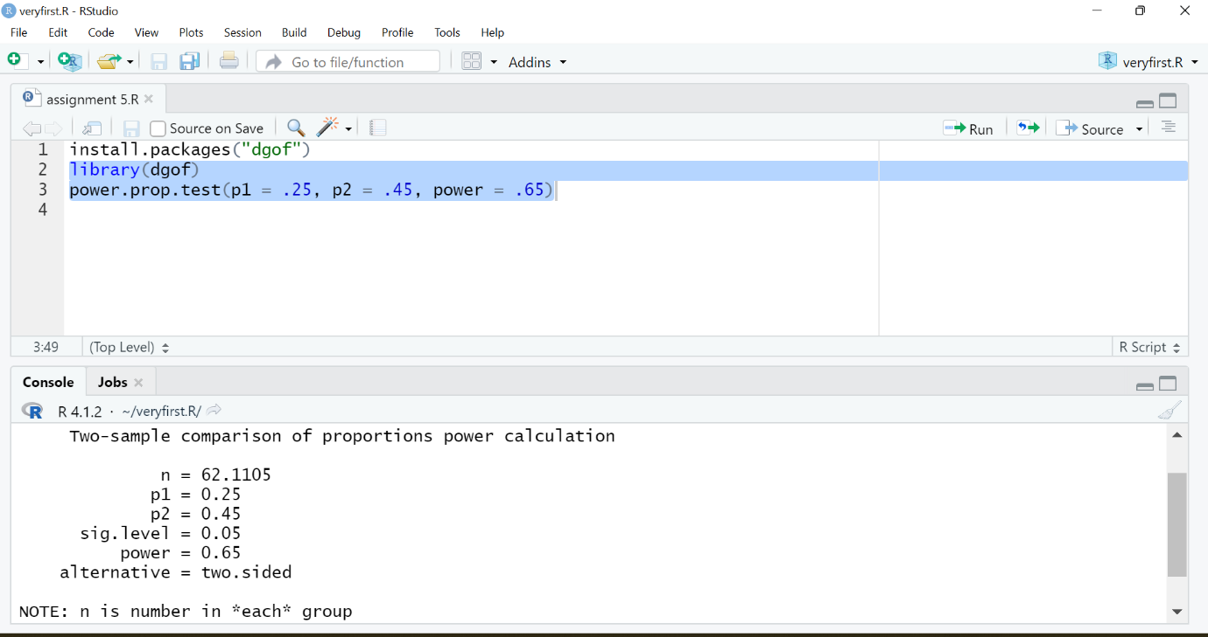

Output:

Two-sample comparison of proportions power calculation

n = 62.1105

p1 = 0.25

p2 = 0.45

sig.level = 0.05

power = 0.65

alternative = two.sided

NOTE: n is number in *each* group